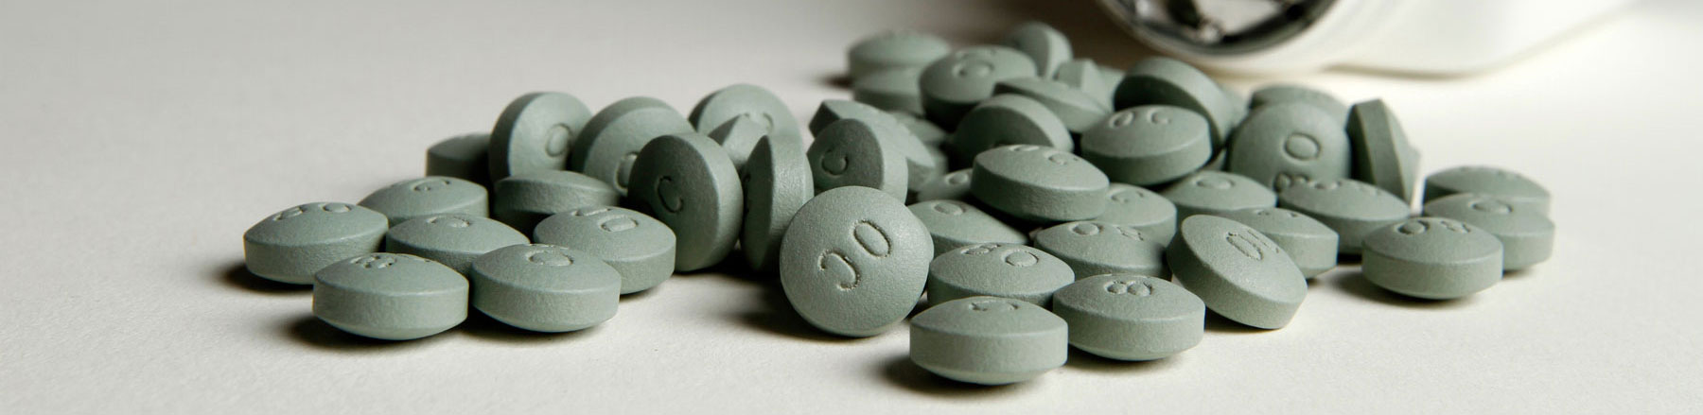OxyContin 80 pills (Liz Baylen / Los Angeles Times)

A TIMES INVESTIGATION

‘YOU WANT A DESCRIPTION OF HELL?’ OXYCONTIN’S 12-HOUR PROBLEM
by HARRIET RYAN, LISA GIRION AND SCOTT GLOVER
MAY 5, 2016
The drugmaker Purdue Pharma launched OxyContin two decades ago with a bold marketing claim: One dose relieves pain for 12 hours, more than twice as long as generic medications.
Patients would no longer have to wake up in the middle of the night to take their pills, Purdue told doctors. One OxyContin tablet in the morning and one before bed would provide “smooth and sustained pain control all day and all night.”
1996
OxyContin Press Release
When Purdue unveiled OxyContin in 1996, it touted 12-hour duration.

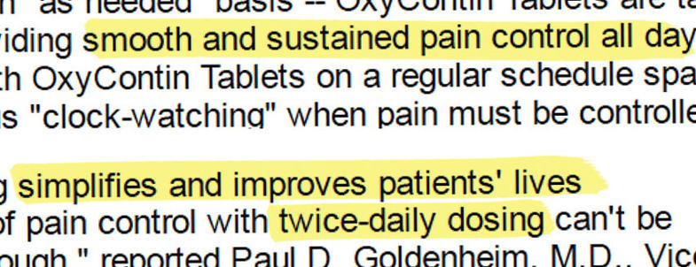

On the strength of that promise, OxyContin became America’s bestselling painkiller, and Purdue reaped $31 billion in revenue.
But OxyContin’s stunning success masked a fundamental problem: The drug wears off hours early in many people, a Los Angeles Times investigation found. OxyContin is a chemical cousin of heroin, and when it doesn’t last, patients can experience excruciating symptoms of withdrawal, including an intense craving for the drug.
The problem offers new insight into why so many people have become addicted to OxyContin, one of the most abused pharmaceuticals in U.S. history. The Times investigation, based on thousands of pages of confidential Purdue documents and other records, found that:
- Purdue has known about the problem for decades. Even before OxyContin went on the market, clinical trials showed many patients weren’t getting 12 hours of relief. Since the drug’s debut in 1996, the company has been confronted with additional evidence, including complaints from doctors, reports from its own sales reps and independent research.
- The company has held fast to the claim of 12-hour relief, in part to protect its revenue. OxyContin’s market dominance and its high price — up to hundreds of dollars per bottle — hinge on its 12-hour duration. Without that, it offers little advantage over less expensive painkillers.
- When many doctors began prescribing OxyContin at shorter intervals in the late 1990s, Purdue executives mobilized hundreds of sales reps to “refocus” physicians on 12-hour dosing. Anything shorter “needs to be nipped in the bud. NOW!!” one manager wrote to her staff.
- Purdue tells doctors to prescribe stronger doses, not more frequent ones, when patients complain that OxyContin doesn’t last 12 hours. That approach creates risks of its own. Research shows that the more potent the dose of an opioid such as OxyContin, the greater the possibility of overdose and death.
- More than half of long-term OxyContin users are on doses that public health officials consider dangerously high, according to an analysis of nationwide prescription data conducted for The Times.
Over the last 20 years, more than 7 million Americans have abused OxyContin, according to the federal government’s National Survey on Drug Use and Health. The drug is widely blamed for setting off the nation’s prescription opioid epidemic, which has claimed more than 190,000 lives from overdoses involving OxyContin and other painkillers since 1999.
The internal Purdue documents reviewed by The Times come from court cases and government investigations and include many records sealed by the courts. They span three decades, from the conception of OxyContin in the mid-1980s to 2011, and include emails, memos, meeting minutes and sales reports, as well as sworn testimony by executives, sales reps and other employees.
The documents provide a detailed picture of the development and marketing of OxyContin, how Purdue executives responded to complaints that its effects wear off early, and their fears about the financial impact of any departure from 12-hour dosing.
Reporters also examined Food and Drug Administration records, Patent Office files and medical journal articles, and interviewed experts in pain treatment, addiction medicine and pharmacology.
Experts said that when there are gaps in the effect of a narcotic like OxyContin, patients can suffer body aches, nausea, anxiety and other symptoms of withdrawal. When the agony is relieved by the next dose, it creates a cycle of pain and euphoria that fosters addiction, they said.
OxyContin taken at 12-hour intervals could be “the perfect recipe for addiction,” said Theodore J. Cicero, a neuropharmacologist at the Washington University School of Medicine in St. Louis and a leading researcher on how opioids affect the brain.
Patients in whom the drug doesn’t last 12 hours can suffer both a return of their underlying pain and “the beginning stages of acute withdrawal,” Cicero said. “That becomes a very powerful motivator for people to take more drugs.”
Peter Przekop, a neuroscientist and physician who oversees the treatment of painkiller addicts at the Betty Ford Center in Rancho Mirage, said that repeated episodes of withdrawal from OxyContin “absolutely” raise the risk that patients will abuse the medication.
“You are messing with those areas of the brain that are involved in addiction, and you are going to get the person dependent on it,” he said.
The Times sought comment from Purdue’s scientists and executives. At the company’s request, the newspaper submitted detailed questions in writing. Purdue responded with a one-page statement noting that the FDA approved OxyContin as a 12-hour drug.
“Scientific evidence amassed over more than 20 years, including more than a dozen controlled clinical studies, supports FDA’s approval of 12-hour dosing for OxyContin,” Purdue’s chief medical officer, Dr. Gail Cawkwell, said.
‘Remember, effective relief just takes two’
Purdue developed OxyContin as a cure for pain — and for a financial problem.
The company’s owners were the Sacklers, a New York family of physicians and philanthropists who bought Purdue in 1952. By the late 1980s, the patent on its main source of revenue, a morphine pill for cancer patients called MS Contin, was running out. Executives anticipated a massive loss of revenue as generic versions drove down the price of MS Contin, according to internal company correspondence from the period.
The company was focused on finding a new moneymaker. In a 1990 memo, Robert F. Kaiko, vice president for clinical research, laid out why it was important to develop a second painkiller.
“MS Contin may eventually face such serious generic competition that other controlled-release opioids must be considered,” Kaiko wrote.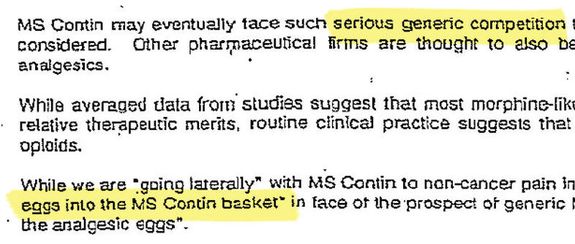
In this 1990 memo, Robert Kaiko, the scientist who would go on to help invent OxyContin, explains why Purdue needs another painkiller.

Purdue already had developed a technique to stretch a drug’s release over time. In MS Contin, the technique made morphine last eight to 12 hours. Kaiko and his colleagues decided to use it on an old, cheap narcotic, oxycodone.
Sold under several names and formulations, including Percocet and Roxicodone, oxycodone controls pain for up to six hours.
With the delayed-release technique, executives theorized, the drug would last 12 hours — at least twice as long as generics and the high end of MS Contin’s range.
Over the next decade, Purdue sunk more than $40 million into development of OxyContin, Paul D. Goldenheim,then-vice president of scientific and medical affairs, wrote in a 2003 court declaration.
Sales and marketing representatives gathered at the company’s headquarters, then in Norwalk, Conn., in March 1995 to start planning the roll-out of the new drug.
“OxyContin can cure the vulnerability of the ... generic threat and that is why it is so crucial that we devote our fullest efforts now to a successful launch of OxyContin,” then chief executive Michael Friedman told the group, according to minutes of the meeting.

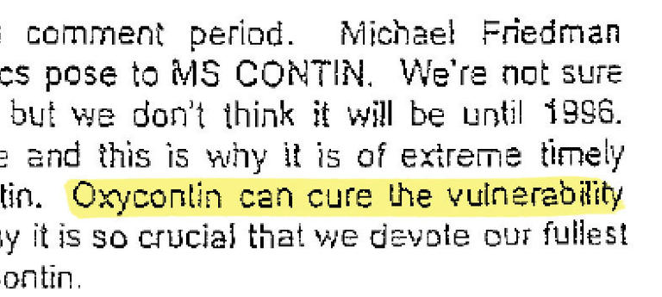
At a 1995 meeting, Purdue executives described how OxyContin could "cure" the "vulnerability" of generic competition and laid out how they planned to market the drug.

The first patients to use OxyContin were women recuperating from abdominal and gynecological surgery at two hospitals in Puerto Rico in 1989. In the clinical study, designed and overseen by Purdue scientists and paid for by the company, 90 women were given a single dose of the drug while other patients were given short-acting painkillers or placebos. None of the women were regular users of painkillers, so they were more susceptible to the effects of narcotics.
Even so, more than a third of the women given OxyContin started complaining about pain in the first eight hours and about half required more medication before the 12-hour mark, according to an FDA analysis of the study.
The study found that OxyContin was safe, relieved pain and lasted longer than the short-acting painkillers.
Purdue moved ahead on two paths: seeking patents for its new drug and running additional clinical trials to secure FDA approval.
In a 1992 submission to the Patent Office, the company portrayed OxyContin as a medical breakthrough that controlled pain for 12 hours “in approximately 90% of patients.” Applying for a separate patent a few years later, Purdue said that once a person was a regular user of OxyContin, it “provides pain relief in said patient for at least 12 hours after administration.”
Purdue’s researchers, meanwhile, were conducting at least a half dozen clinical trials, according to the company’s FDA application. In study after study, many patients given OxyContin every 12 hours would ask for more medication before their next scheduled dose.
For example, in one study of 164 cancer patients, one third of those given OxyContin dropped out because they found the treatment “ineffective,” according to an FDA analysis of the study. Researchers then changed the rules of the study to allow patients to take supplemental painkillers, known as “rescue medication,” in between 12-hour doses of OxyContin.
In another study of 87 cancer patients, “rescue was used frequently in most of the patients,” and 95% resorted to it at some point in the study, according to a journal article detailing the clinical trial.
A Tennessee pain specialist whom Purdue selected to field-test the drug in 1995 as part of the FDA approval process eventually moved 8 of 15 chronic pain patients to 8-hour dosing because they were not getting adequate relief taking the drug twice a day.
This prompted a letter from Purdue’s medical director.
“This situation concerns me as OxyContin has been developed for q12h dosing,” Dr. Robert Reder wrote to the Memphis physician, using medical shorthand for 12-hour dosing. “I request that you not use a q8h dosing regimen.”
Narcotic painkillers work differently in different people. Some drug companies discuss that variability on their product labels and recommend that doctors adjust the frequency with which patients take the drugs, depending on their individual response.
The label for Purdue’s MS Contin, for instance, recommends that doctors prescribe the drug every eight or 12 hours to suit the patient. The morphine tablet, Kadian, manufactured by Actavis, is designed to be taken once a day, but the label states that some patients may need a dose every 12 hours.
Despite the results of the clinical trials, Purdue continued developing OxyContin as a 12-hour drug. It did not test OxyContin at more frequent intervals.
To obtain FDA approval, Purdue had to demonstrate that OxyContin was safe and as effective as other pain drugs on the market. Under agency guidelines for establishing duration, the company had to show that OxyContin lasted 12 hours for at least half of patients. Purdue submitted the Puerto Rico study, which showed that.
The FDA approved the application in 1995.
Dr. Curtis Wright, who led the agency’s medical review of the drug, declined to comment for this article. Shortly after OxyContin’s approval, he left the FDA and, within two years, was working for Purdue in new product development, according to his sworn testimony in a lawsuit a decade ago.
The Times asked the FDA for comment on the drug’s failure to provide 12 hours of relief for many patients. Officials at the agency declined to be interviewed.
In a written statement, spokeswoman Sarah Peddicord said that although the FDA approved OxyContin for use every 12 hours, “it should be well understood by physicians that there will be some individual variability in the length of time that patients respond to this drug...
“While the labeled dosing regimen is a reasonable starting point, physicians should carefully individualize their approach to patients based on how quickly they metabolize the drug,” Peddicord wrote.
After OxyContin hit the market in 1996, ads in medical journals left no ambiguity about how long it lasted. A spotlight illuminated two dosage cups, one marked 8 AM and the other 8 PM.
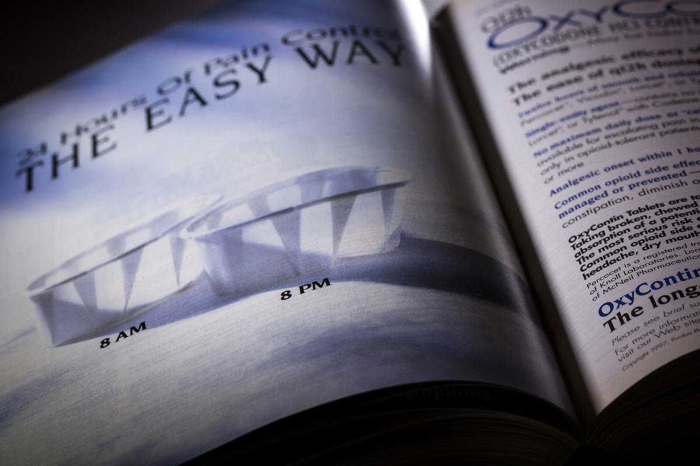
A 1997 OxyContin advertisement in the American Family Physician shows marketing promoting the benefits of 12-hour dosing. (Liz. O. Baylen / Los Angeles Times)

‘What time is it? Oh, God, I have to medicate'
The year OxyContin was introduced, Elizabeth Kipp, a 42-year-old stay-at-home mom, went to her doctor in Kansas City, Kan. She had struggled with back pain since age 14, when she was thrown from a horse while practicing for an equestrian competition.
In the intervening decades, she’d taken short-acting generic painkillers. On that day in 1996, her physician said he had something new for her to try.
He told her to take OxyContin every 12 hours. Kipp, who had a bachelor’s degree in plant science from the University of Delaware, said she followed his instructions precisely.
“I’m a scientist, very regimented,” she said.
For the first two or three hours, she experienced a “small amount of relief.” Then her pain roared back, accompanied by nausea, she said in an interview. Only the next pill would relieve her suffering.
She spent hours lying rigidly on her bed, waiting.
“I was watching the clock. ‘What time is it? Oh, God, I have to medicate,' ” she said. “My whole nervous system is on red alert.”
“You want a description of hell? I can give it to you.”

— Elizabeth Kipp
When she complained to her doctor, he gave her stronger doses but kept her on the 12-hour schedule, as Purdue instructs physicians to do. The change had little effect.
For a year and a half, she spent each day cycling through misery and relief. Sometimes, she said, she contemplated suicide.
“You want a description of hell,” Kipp recalled. “I can give it to you.”
She eventually checked herself into rehab and said she no longer takes painkillers.
‘It’s Bonus Time in the Neighborhood!’
Before OxyContin, doctors had viewed narcotic painkillers as dangerously addictive and primarily reserved their long-term use for cancer patients and the terminally ill. Purdue envisioned a bigger market.
“We do not want to niche OxyContin just for cancer pain,” a marketing executive explained to employees planning the drug’s debut, according to minutes of the 1995 meeting.
The company spent $207 million on the launch, doubling its sales force to 600, according to a court declaration. Sales reps pitched the drug to family doctors and general practitioners to treat common conditions such as back aches and knee pain. Their hook was the convenience of twice-a-day dosing.
With Percocet and other short-acting drugs, patients have to remember to take a pill up to six times a day, Purdue told doctors. OxyContin “spares patients from anxious ‘clockwatching,’” a 1996 news release said.
Sales reps showered prescribers with clocks and fishing hats embossed with “Q12h.” The company invited doctors to dinner seminars and flew them to weekend junkets at resort hotels, where they were encouraged to prescribe OxyContin and promote it to colleagues back home.
The marketing succeeded in ways that astonished even Purdue executives. OxyContin didn’t just replace MS Contin revenues. It dwarfed them.
By the third year, sales were more than double MS Contin’s peak, according to sworn testimony by a Purdue executive. By the fifth, OxyContin was generating annual revenue of more than $1 billion. Sales would continue to climb until 2010, when they leveled off at $3 billion.
Purdue’s owners, the Sackler family, were already rich — the family name adorns a wing of the Metropolitan Museum of Art and several galleries in the British Museum. The success of OxyContin brought a whole new level of wealth. Forbes magazine last year estimated the Sacklers’ worth at $14 billion, which, the magazine noted, put the family ahead of American dynasties such as the Mellons and Rockefellers.
OxyContin’s impact on the practice of medicine was similarly transformative. Other drug companies began marketing their own narcotic painkillers for routine injuries. By 2010, one out of every five doctor’s visits in the U.S. for pain resulted in a prescription for narcotic painkillers, according to a Johns Hopkins University study.
OxyContin accounted for a third of all sales revenue from painkillers that year, according to industry data.
Rates of addiction and overdose have soared alongside the rise in prescriptions. News coverage of these problems in Appalachia and New England in the late 1990s made OxyContin notorious. Purdue dispatched representatives to Virginia, Maine and elsewhere to defend its drug. They blamed misuse of OxyContin and insisted their pill was a godsend for pain sufferers when taken as directed.
“A lot of these people say, ‘Well, I was taking the medicine like my doctor told me to,’ and then they start taking them more and more and more,” Purdue senior medical director, Dr. J. David Haddox, told a reporter in 2001. “I don’t see where that’s my problem.”
The U.S. Justice Dept. launched a criminal investigation, and in 2007 the company and three top executives pleaded guilty to fraud for downplaying OxyContin’s risk of addiction. Purdue and the executives were ordered to pay $635 million. The case centered on elements of Purdue’s marketing campaign that suggested to doctors that OxyContin was less addictive than other painkillers.
In the years after the settlement, Purdue funded programs to prevent pharmacy robberies and keep teenagers from stealing relatives’ pills. The company eventually rolled out a tamper-resistant version of the painkiller that was harder to crush and snort.
But in all the scrutiny of Purdue and OxyContin, the problem of the drug wearing off early was not addressed.
Purdue sales reps who spent their days visiting doctors to talk up OxyContin heard repeatedly that the drug didn’t last. In reports to headquarters, they wrote that many physicians were prescribing it for three or even four doses a day.
Company officials worried that if OxyContin wasn’t seen as a 12-hour drug, insurance companies and hospitals would balk at paying hundreds of dollars a bottle.
Some already were.
Dr. Lawrence Robbins started prescribing OxyContin at his Chicago migraine clinic shortly after it hit the market. The neurologist recalled in an interview that “70 to 80%” of his patients reported that the drug “just lasts four, five, six, seven hours.” Robbins started telling people to take it more frequently. But insurance carriers often refused to cover the pharmacy bill for more than two pills a day, he said.
Over the years, he wrote insurance companies more than 25 times on behalf of patients who he believed needed OxyContin more frequently than every 12 hours, he said. In some cases, the insurers relented. When others did not, Robbins switched the patients to another drug.
Robbins said he had no choice: “If they are having a real struggle with opioid withdrawal, sure, you have to do something.”
For Purdue, doctors like Robbins were a problem that had to be confronted.
“I am concerned that some physicians are using OxyContin on a q8h schedule rather than a q12h schedule,” a regional manager in Atlanta, Windell Fisher, wrote in November 1996 — 11 months after OxyContin went on sale.

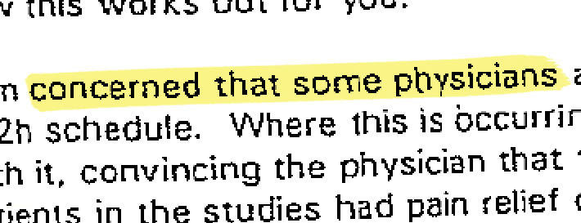
In this 1996 letter, a Purdue regional manager writes that he is concerned about doctors prescribing OxyContin at 8-hour intervals. Sales reps should visit those physicians and convince them to go back to 12-hour dosing, he writes.

In the memo, Fisher told a district sales manager what to do:
“Where this is occurring you need to train the representative on how to deal with it, convincing the physician that there is no need to do this, and that 100% of the patients in the studies had pain relief on a q12h dosing regimen.”
By 2000, it was clear that chiding memos to sales reps weren’t enough. Data analyzed by company employees showed that one in five OxyContin prescriptions was for use every eight hours, or even more frequently.
Purdue held closed-door meetings to retrain its sales force on the importance of 12-hour dosing, according to training documents, some included in sealed court files and others described in FDA files.
“These numbers are very scary,” managers warned sales reps during one workshop.

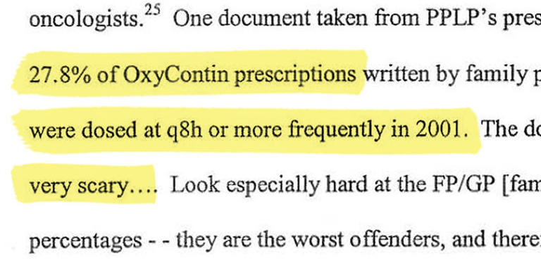
In a 2004 petition to the FDA, attorneys for the state of Connecticut described the alarm inside Purdue when some doctors began prescribing OxyContin at more frequent intervals. "These numbers are very scary," sales reps were told.

“Managed care plans are beginning to refuse to fill prescriptions,” they were told in another presentation. Reps were ordered to visit doctors and “refocus the clinician back to q12h.” Doctors needed to be reminded “on every call,” they were told.
“There is no Q8 dosing with OxyContin,” one sales manager told her reps, according to a memo cited in an FDA filing. She added that 8-hour dosing “needs to be nipped in the bud. NOW!!”
If a doctor complained that OxyContin didn’t last, Purdue reps were to recommend increasing the strength of the dose rather than the frequency. There is no ceiling on the amount of OxyContin a patient can be prescribed, sales reps were to remind doctors, according to the presentation and other training materials.

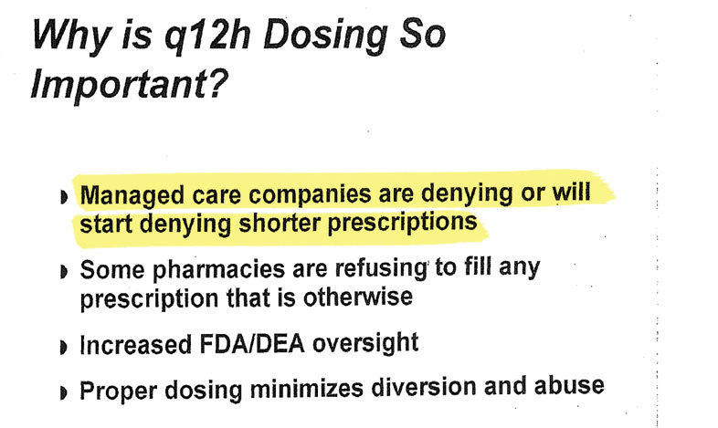
After some physicians began prescribing OxyContin more frequently than every 12 hours, Purdue summoned its sales force to special seminars. As this 2001 presentation shows, company officials were concerned more frequent dosing would hurt business.

Boosting the dosage could extend the duration to some degree, but it didn’t guarantee 12 hours of relief. Higher doses did mean more money for Purdue and its sales reps. The company charged wholesalers on average about $97 for a bottle of the 10-milligram pills, the smallest dosage, while the maximum strength, 80 milligrams, ran more than $630, according to 2001 sales data the company disclosed in litigation with the state of West Virginia. Commissions and performance evaluations for the sales force were based in part on the proportion of sales from high-dose pills.
A West Virginia supervisor told one of his highest performing sales reps in a 1999 letter that she could “blow the lid off” her sales and earn a trip to Hawaii if she persuaded more doctors to write larger doses.
In an August 1996 memo headlined “$$$$$$$$$$$$$ It’s Bonus Time in the Neighborhood!” a manager reminded Tennessee reps that raising dosage strength was the key to a big payday.

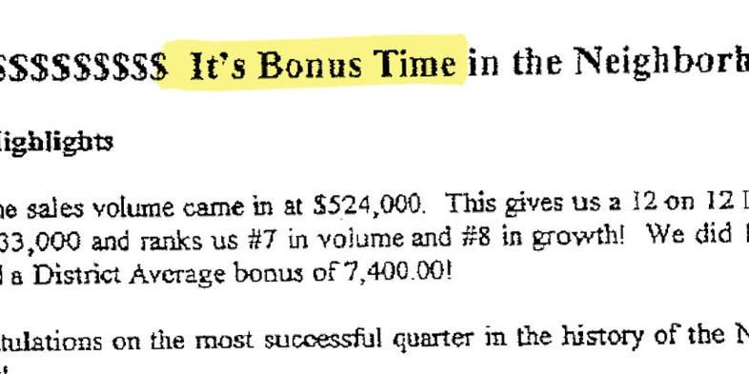
In this 1996 memo entitled "It's Bonus Time in the Neighborhood," a Purdue sales manager told her staff to talk up stronger doses of OxyContin in conversations with doctors.

“He who sells 40mg” the largest pill available at the time “will win the battle,” the manager wrote.
By 2004, Purdue was seeing “a trend away from prescribing OxyContin” more frequently than every 12 hours, according to a company filing with the FDA.
In the training materials reviewed by The Times, little was said about the effect of higher doses on patient health. Those on higher doses of opioids are more likely to overdose, according to numerous research studies. An analysis of the medical records of more than 32,000 patients on OxyContin and other painkillers in Ontario, Canada, found that one in 32 patients on high doses fatally overdosed.
“In other words,” the lead researcher, David Juurlink, said in an interview, “they are more likely to die as a result of their medication than almost anything else.”
‘Death was looking real good to me’
As a varsity athlete at the University of Central Florida and later a public school teacher, Burgess MacNamara was used to following rules.
That changed in 1999 when he had knee surgery and his doctor put him on OxyContin. MacNamara, then a 27-year-old gym teacher at an elementary school near Orlando, was familiar with painkillers. He’d been given Percocet and Vicodin for sports injuries, but he said OxyContin was unlike anything he’d ever experienced.
“The first six hours, it is awesome,” he said. Then the effect began to “teeter off” and he became preoccupied with his next dose: “That’s all you think about. Your whole day revolves around that.”
MacNamara said he soon began taking pills early.
“I can’t even tell you the times I actually waited 12 hours,” he said. “There weren’t many of them.”
“Death was looking real good to me. ”

— Burgess MacNamara

Within a month, he was crushing and snorting the pills. Within a year, he was forging prescriptions. He eventually tried heroin, which was cheaper, and other drugs. MacNamara was arrested for forging prescriptions, possession of controlled substances, stealing pills from a school clinic and other drug-fueled crimes. He lost his teaching career and spent 19 months behind bars.
“Death was looking real good to me,” recalled MacNamara, who said he has been sober for the last two and a half years.
‘I was more or less a zombie’
As OxyContin’s popularity grew, a handful of scientists outside Purdue published research raising questions about the 12-hour claim. Scientists affiliated with the Oklahoma University College of Medicine found in 2002 that nearly 87% of those prescribed OxyContin at a school pain clinic were taking it more frequently than every 12 hours. The reason, researchers wrote, was “perceived end-of-dose failure.”
A separate study underwritten by a Purdue competitor, Janssen Pharmaceutica, reached a similar conclusion. Researchers surveyed chronic pain patients treated with OxyContin and reported that less than 2% said the drug lasted 12 hours and nearly 85% said it wore off before eight, according to a 2003 journal article detailing the research.
In the real world practice of medicine, some doctors turned away from OxyContin entirely. San Francisco public health clinics stopped dispensing the painkiller in 2005, based in part on feedback from patients who said it wore off after eight hours. The clinics switched to generic morphine, which has a similar duration and costs a lot less.
“What I had come to see was the lack of evidence that it was any better than morphine,” Dr. Mitchell Katz, then head of the San Francisco public health department, said in an interview.
What I had come to see was the lack of evidence that it was any better than morphine,” Dr. Mitchell Katz, then head of the San Francisco public health department, said in an interview.

Patients began filing lawsuits in the early 2000s that accused Purdue of overstating OxyContin’s duration, among other complaints. One of the plaintiffs was a retired Alabama businessman named H. Jerry Bodie.
His doctor had Bodie on 30 milligrams of OxyContin every eight hours for chronic back pain. A Purdue sales rep persuaded him to switch Bodie to a higher dose every 12 hours, according to a judge's summary of the evidence.
Bodie returned to his doctor repeatedly, saying the drug wasn’t working, according to their sworn testimony. The doctor kept raising the dose, eventually putting Bodie on 400 milligrams a day.
“I was more or less just a zombie,” Bodie said in a deposition.
Bodie’s lawsuit and hundreds of others filed by OxyContin users and their families never got before a jury. Purdue got suits dismissed by asserting, among other defenses, a legal doctrine which shields drug companies from liability when their products are prescribed by trained physicians. Purdue settled other lawsuits on confidential terms.

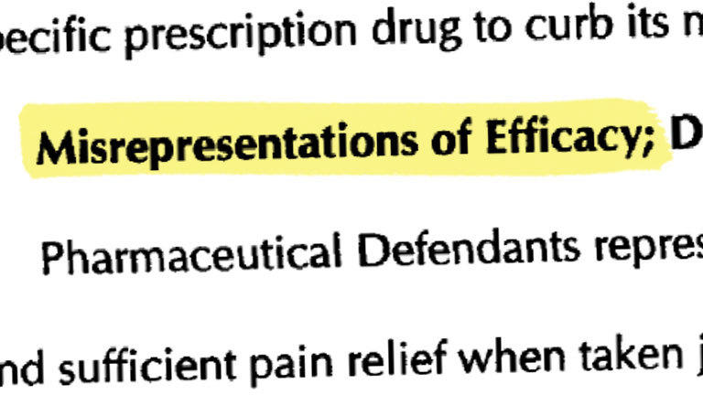
In a 2002 federal suit, Alabama businessman H. Jerry Bodie accused Purdue of overstating the duration of OxyContin, among other complaints. The lawsuit was dismissed.

In these legal battles, the company successfully petitioned courts to have evidence sealed, citing the need to protect trade secrets. The sealed materials included internal memos to members of the Sackler family and others, FDA correspondence, testimony from executives and sales reps’ reports.
They remain sealed to this day. The Times reviewed thousands of pages of them.
In the fall of 2004, in a remote courthouse in Appalachia, the 12-hour dosing issue came close to a public airing. The West Virginia attorney general was pressing a lawsuit against Purdue demanding reimbursement of “excessive prescription costs” paid by the state through programs for the poor and elderly. The state accused the company of deceptive marketing, including the 12-hour claim.
Frances Hughes, then the state’s chief deputy attorney general, said the last allegation grew out of investigators’ interviews with addicts and their families. In describing problems with OxyContin, many said the drug wore off hours early.
“What was happening was that they were taking more than they were prescribed because the pain medication wasn’t working,” Hughes recalled in an interview.
Purdue’s legal team made numerous attempts to get the suit dismissed or moved from state to federal court, where the company had succeeded in getting many cases tossed out. All these efforts failed.
Purdue had one final shot at avoiding trial: A motion for summary judgment. The judge hearing the case in rural McDowell County was Booker T. Stephens, son of a local coal miner and the first African American elected to the West Virginia circuit court.
To make this critical argument, the company tapped Eric Holder Jr., who had been the nation’s first African American deputy attorney general. On Oct. 13, 2004, the man who would become President Obama’s attorney general argued that West Virginia prosecutors didn’t have sufficient evidence to warrant a trial.
Stephens disagreed. He ruled that there was enough evidence that a jury could find Purdue had made misleading claims about OxyContin, including how long it lasted.
“Most of the patients in the clinical trials required additional medication, so called ‘rescue medications,’ that accompanied their 12-hour OxyContin dose,” the judge wrote in his Nov. 5, 2004 ruling. “Plaintiff’s evidence shows Purdue could have tested the safety and efficacy of OxyContin at eight hours, and could have amended their label, but did not.”
His decision meant that for the first time, questions about OxyContin's duration would be aired at a trial. Sealed evidence would be laid out in public for class-action attorneys, government investigators, doctors and journalists to see.
On the eve of trial, Purdue agreed to settle the case by paying the state $10 million for programs to discourage drug abuse. All the evidence under seal would remain confidential.
A week later, Judge Stephens ordered one more document withdrawn from public view: His Nov. 5 ruling that there was enough evidence against Purdue to warrant a trial. The Times reviewed a copy of the ruling.
The settlement did not require Purdue to admit any wrongdoing or change the way it told doctors to prescribe the drug.
‘A significant competitive advantage’
While Purdue’s litigators were working in courthouses around the country to fend off civil suits, its regulatory attorneys in Washington, D.C., made a blunt admission to the FDA: The 12-hour dosing schedule is, at least in part, about money.
The issue arose in a regulatory dispute that attracted little attention. The Connecticut attorney general had complained to the FDA that doctors prescribing OxyContin every eight hours, rather than the recommended 12, were unintentionally fueling black market use of the drug.
In a 2004 letter to the FDA, Purdue lawyers responded that the company had no evidence that eight-hour prescribing contributed to abuse or was unsafe. They went on to make a case far different than the one Purdue sales reps were making to doctors. Eight-hour dosing, the attorneys wrote, could “optimize treatment” for some patients and should level out the narcotic roller coaster.
Nonetheless, they said the company planned to continue telling doctors OxyContin was a 12-hour drug. The lawyers gave a list of reasons: Purdue hadn’t submitted studies to the FDA to support more frequent dosing, the FDA had approved OxyContin as a 12-hour drug, and 12-hour dosing was more convenient for patients.
Their final reason: It was better for business.
“The 12 hour dosing schedule represents a significant competitive advantage of OxyContin over other products,” the lawyers wrote.
‘Is it just me or does oxycontin not even last 8 hours’
In the years that followed, attacks on the 12-hour claim largely dropped from the agenda of Purdue’s critics. The federal investigation was over. Class-action attorneys moved on to other drugs.
For many patients, the problem never went away.
OxyContin “does a great job of keeping me out of a wheelchair and moving...for 8 hours. Then I start going into withdrawal,” one patient wrote on an online message board in 2004.
“Is it just me, or does oxycontin not even last 8 hours,” another asked in 2008.
“I thought I had to be nuts,” one woman from Florida wrote in 2013 after learning that others also found the drug wore off early. “I am really falling apart from the anxiety.”
Earlier this year, a man posting to a chat board for pain patients said he got six to eight hours of relief from OxyContin, but hadn't been able to convince his doctor to prescribe it more frequently.
"I find it misleading how a product can be marketed as lasting 12 hours when it doesn't," he wrote of his experience.
For a brief moment three years ago, it seemed the problems with 12-hour dosing might get wider attention. The FDA had called for public input on how to make painkiller labels safer. Dr. David Egilman, a Brown University professor of family medicine who had served as a plaintiff’s expert in unsuccessful suits against Purdue, saw it as an opportunity to alert agency officials to problems with OxyContin’s 12-hour claim.
Egilman, an expert in warning labels, had worked on hundreds of product liability cases ranging from asbestos to microwave popcorn. He had developed a reputation as a plaintiff’s advocate driven to expose corporate wrongdoing.
Some judges said he went too far. In a 2007 case against the drugmaker Eli Lilly, for example, a judge found that Egilman leaked confidential documents about the controversial antipsychotic medication Zyprexa to a New York Times reporter. He agreed to pay the company $100,000. In the OxyContin cases, Purdue had attacked his ethics and qualifications.
When FDA officials convened the hearing in a suburban Maryland hotel ballroom Feb. 8, 2013, Egilman was out of the country. He submitted a PowerPoint presentation to be played in his absence.
In the five-minute presentation, Egilman accused Purdue of ignoring its own science for financial reasons and sending patients on a dangerous roller coaster of withdrawal and relief.
“In other words,” he said, “the Q12 dosing schedule is an addiction producing machine.”
Egilman noted that he had reviewed confidential Purdue documents and sealed testimony of company executives through his work as an expert witness. But, he said, because of court orders sought by Purdue, he was barred from revealing what he’d read in those documents or giving them to the FDA. (He also declined to share the records with The Times.)
A snowstorm was bearing down on the East Coast that day, and the hearing room was nearly deserted. When the presentation concluded, there was a brief pause, and then the FDA moderator moved on to the next speaker.
Neither Purdue nor the agency ever responded to Egilman’s presentation.
‘The higher you go, the more likely you are to die’
OxyContin is still hugely popular. Doctors wrote 5.4 million prescriptions for the painkiller in 2014, and according to a Purdue spokesman, 80% were for 12-hour dosing.
After years of the company telling doctors to answer complaints about duration with greater strengths of OxyContin, many patients are taking the drug at doses that public health officials now consider dangerously high.
At The Times’ request, scientists at the University of Arkansas for Medical Sciences analyzed OxyContin prescriptions in a database of insurance claims covering about 7 million patients across the country.
In 2014, the analysis found, more than 52% of patients taking OxyContin longer than three months were prescribed doses greater than 60 milligrams a day. Guidelines issued this year by the Centers for Disease Control and Prevention urged physicians to “avoid” or “carefully justify” prescriptions of that strength.
Told of the Arkansas analysis, Dr. Debra Houry, director of the CDC’s National Center for Injury Prevention and Control and a leader of the agency’s response to the opioid epidemic, called it “really concerning.”
“The higher you go, the more likely you are to die,” she said.
To this day, physicians frequently contact Purdue with questions about dosing. Only 12-hour dosing has been proved safe, the company tells them.

