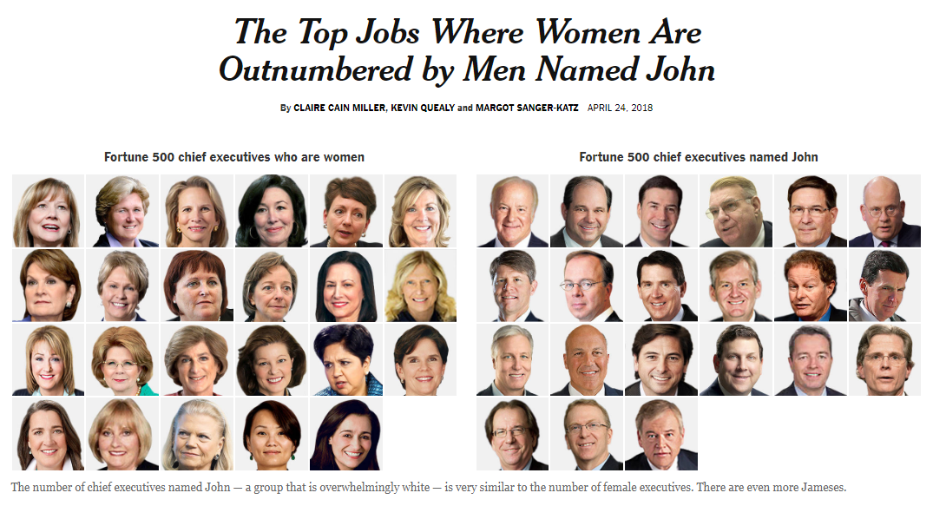
In the corridors of American power, it can be as easy to find a man named John as it is to find a woman.
Fewer Republican senators are women than men named John — despite the fact that Johns represent 3.3 percent of the male population, while women represent 50.8 percent of the total population. Fewer Democratic governors are women than men named John. And fewer women directed the top-grossing 100 films last year than men named Michael and James combined.
These comparisons come from our updated and expanded Glass Ceiling Index, in which we counted the women and men in important leadership roles in American life — including politics, law, business, tech, academia, film and media.
Of the groups of leaders we examined, chief executives and directors of last year’s top-grossing films have the lowest rates of women. Top venture capitalists and House Republicans were next, followed by groups of politicians from both parties: Republican senators and governors, and Democratic governors.
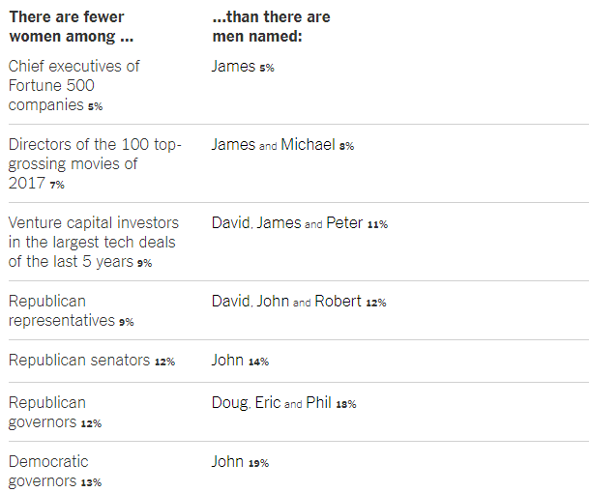
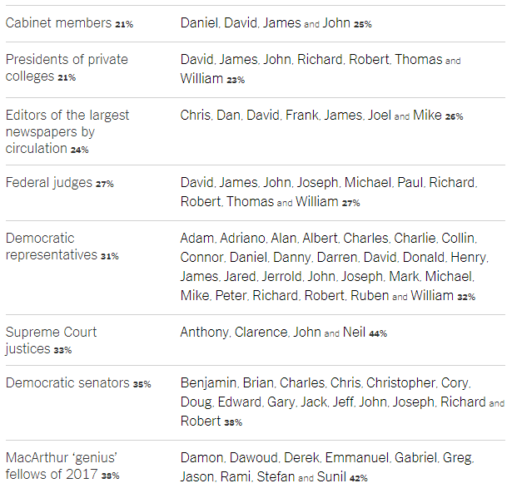

Of the 24 MacArthur Foundation “genius” grant winners this year, nine were women, and none of the men were named John. That group, chosen by a committee for its creativity, diversity of thought and “promise for important future advances,” was more diverse than other groups in many ways, and that was reflected in the group’s gender ratio and the names of its men. The only category we examined in which more than half of leaders were women — about 52 percent — was editors of the top 50 magazines by circulation. This may be because many of the most popular magazines are about fashion and lifestyle, and cater to women.
Our index was inspired by a 2015 report by Ernst & Young, which found that women made up 16 percent of board members of companies on the S.&P. 1500, less than the share of board seats held by men named John, Robert, James and William. That number has improved slightly: 19 percent of board members are now women, according to updated numbers from Ernst & Young. (The company has not updated its count of board members with particular names.)
The Upshot first published the Glass Ceiling Index three years ago. Justin Wolfers, an economist and an Upshot contributor, looked at various categories and calculated the ratio of women to men who had four of the most common male names. Since then, the proportion of women at the top hasn’t improved much.
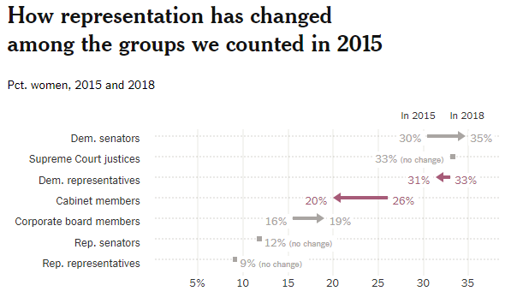

This time, we examined the question a little differently: How many male names, starting with the most common names in each group, does it take to outnumber all women? In some cases — among Republican senators, Democratic governors or the chief executives of Fortune 500 companies, for example — the men named John were enough to reach parity or come close. In several other institutions, it took only two male names to overtake the women.
Our lists of names come from different organizations. Most are current, but a few have time lags based on when data was collected.
The prevalence of men in power with particular names is revealing not only of skewed gender representation, but also of the whiteness of many institutions of American politics, culture and education. White men continue to dominate many categories of leadership in America, as our Times colleagues showed in an analysis in 2016.
Women earn more college degrees than men and increasingly work in occupations that used to be male-dominated, and yet their progress to positions of power has been slowed or stalled. There are many reasons for this, researchers say. Women are more likely to take breaks from their careers to raise children. Men at the top are more likely to mentor and promote people like themselves.
Women also face double standards: People in power need to be assertive and ambitious, but women are often criticized for acting that way.
One of the biggest reasons women are so outnumbered at the top, studies show, is discrimination.
The Glass Ceiling Index could change if more women fill the workplace pipeline — but many of these obstacles have persisted despite the presence of more than enough qualified women to do the jobs. More likely, what will change sooner are the names of the men in charge — fewer Johns and Roberts and more Liams and Noahs.

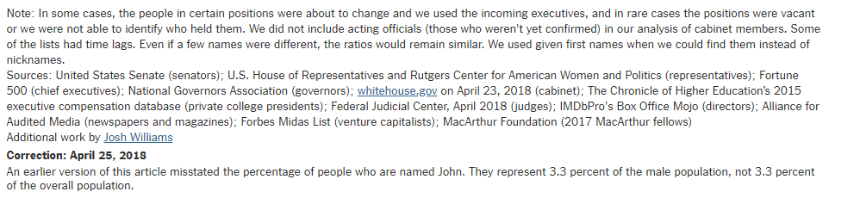
Some ‘Comments’ Curated by Smith: respond to them as if this was the NYT page.
